**Q.Lost SSH Key on AWS? Here’s How to Regain Access to Your EC2 Instances without downtime”**

**1. Launch 1 ec2-instance and connect via local terminal using :**

ssh -i keypair ec2-user@pub-IP

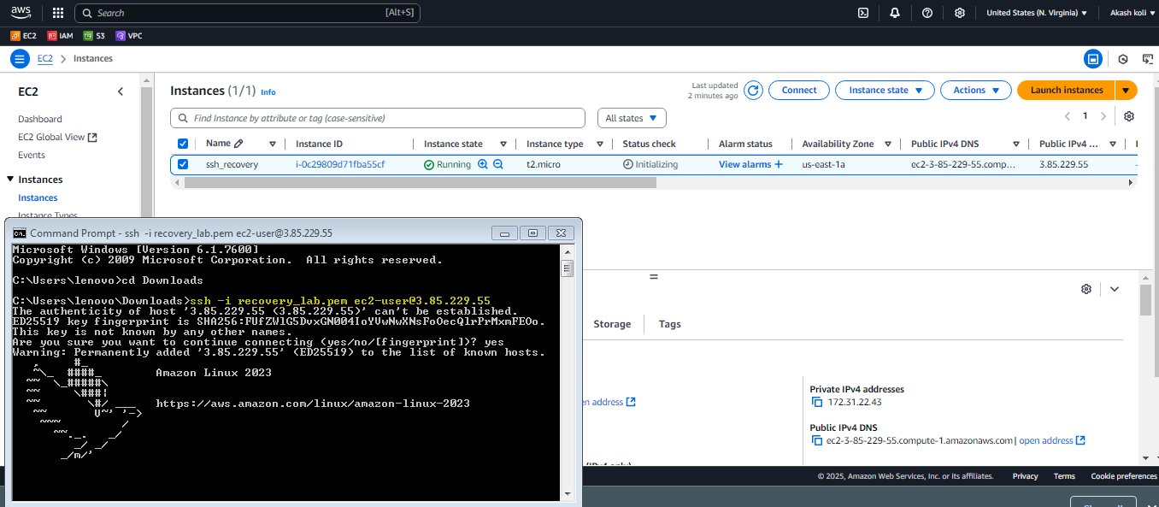

2.Now delete the private key from your local machine and try acess again just to see the login fail. 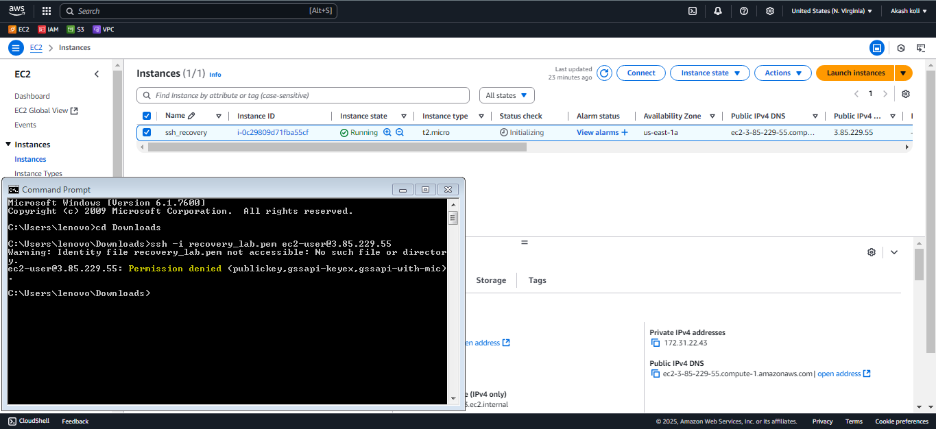

*3.* Now let us access our vm via direct connect.& generate key.

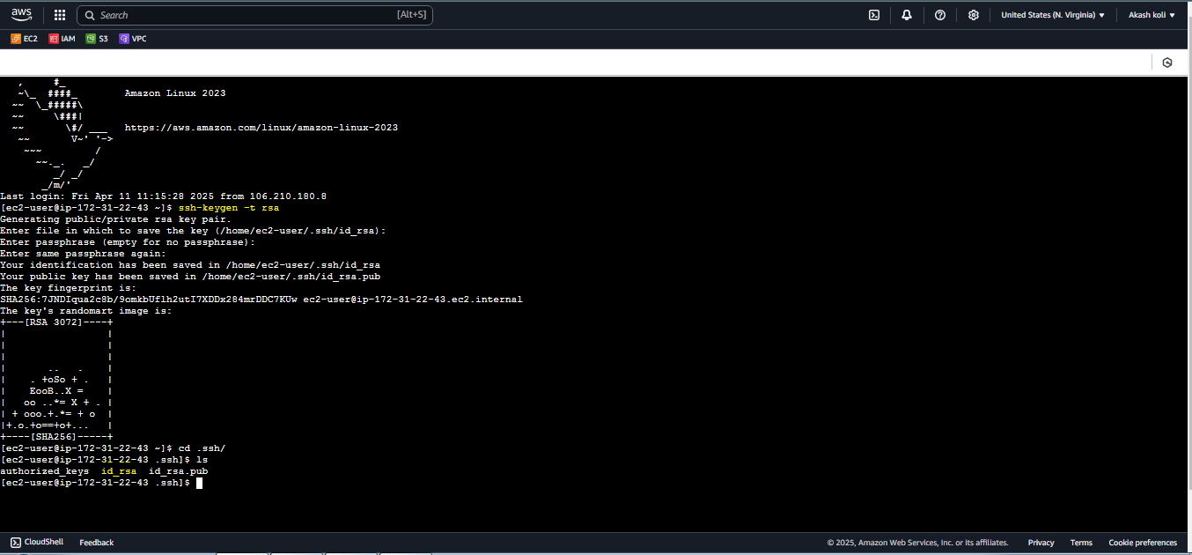

*4. The command****ssh-keygen -p -m PEM -f id_rsa****is used to convert the format of an existing private SSH key (id_rsa) to the PEM format and optionally change its passphrase. Here’s a breakdown of the command:*

*Copy the key* **Save this as .pem file in your system**

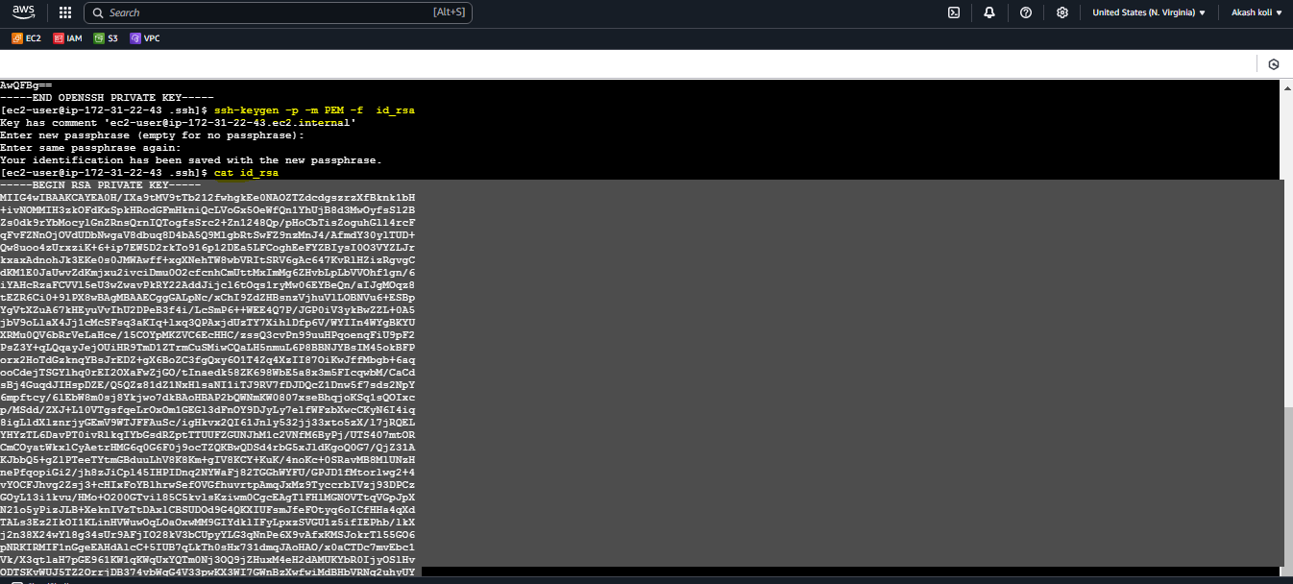

*5.* *Now let us copy the new public key to authorized_keys where your old lost public key was present.*

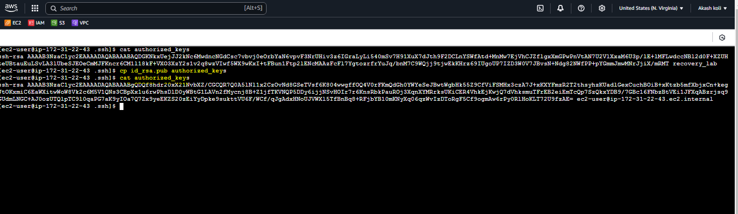

*6.Check with new key :It works!!!*

